HOSPITAL MANAGEMENT SYSTEM
First Project Review
Doctor Login • Super Admin Login • Patient Login • Receptionist Login
Focus: Faster Hospital Operations and Reduced Time Consumption

TABLE OF CONTENTS
1. PROBLEM DEFINITION
2. OBJECTIVES
3. CORE COMPONENTS / MODULES
4. PROJECT PROFILE
5. NEED OF THE SYSTEM
6. SCOPE OF THE PROJECT
7. ADVANTAGES OF HOSPITAL MANAGEMENT SYSTEM
8. LIMITATIONS OF HOSPITAL MANAGEMENT SYSTEM
9. TIMELINE CHART
10. TARGETED USERS
11. REQUIREMENT DETERMINATION AND ANALYSIS
12. REQUIREMENT DETERMINATION
13. REQUIREMENT SPECIFICATION
14. SYSTEM DESIGN
15. USE CASE DIAGRAM

1. PROBLEM DEFINITION
Hospitals handle a large amount of information every day, including patient registration, doctor schedules, appointments, medical records, prescriptions, billing, and reports. When these activities are managed manually or through separate systems, staff may spend more time searching, entering, and updating information. This can create delays, duplicate work, paperwork, and difficulty in maintaining accurate records.
The proposed Hospital Management System is a web-based system designed to reduce time consumption and simplify hospital operations. The system will provide separate secure logins for Doctor, Super Admin, Patient, and Receptionist. Each user will get access to functions according to their role. The system will centralize patient information, appointments, doctor information, prescriptions, billing, and reports so that required information can be accessed quickly.

2. OBJECTIVES
The main objective of the Hospital Management System is to digitize and streamline hospital activities so that routine work can be completed in less time.
- To provide a centralized system for managing hospital information.
- To provide separate and secure login access for Doctor, Super Admin, Patient, and Receptionist.
- To reduce the time required for patient registration and appointment management.
- To allow receptionists to quickly manage patients and appointments.
- To allow doctors to view patient records and manage prescriptions efficiently.
- To allow patients to view their appointments and relevant medical information.
- To allow the Super Admin to manage users, doctors, patients, and overall hospital records.
- To reduce paperwork, duplicate data entry, and manual searching.
- To improve the accuracy, availability, and security of hospital information.
- To generate useful reports and dashboards for hospital administration.

3. CORE COMPONENTS / MODULES
1. Super Admin Module
The Super Admin has overall control of the system. The admin can manage doctors, receptionists, patients, user accounts, hospital information, reports, and system activities.
2. Doctor Module
Doctors can securely log in, view assigned appointments, access authorized patient records, add diagnosis details, create prescriptions, and update treatment information.
3. Patient Module
Patients can log in to view their profile, appointments, doctor details, prescriptions, and available medical information. The module reduces the need for patients to repeatedly visit the reception desk for basic information.
4. Receptionist Module
Receptionists can register patients, manage appointments, check doctor availability, update basic patient information, and handle billing-related activities as authorized.
5. Appointment Management Module
This module manages appointment booking, doctor schedules, appointment status, and appointment history. It helps reduce waiting and scheduling time.
6. Patient Management Module
This module stores and manages patient registration details, contact information, visit history, and authorized medical records.
7. Prescription and Medical Record Module
Doctors can enter prescriptions and medical notes, while authorized users can access information according to their role.
8. Billing Module
The billing module records consultation and other applicable charges and helps generate billing information quickly.
9. Database and Data Management Module
The database stores users, patients, doctors, appointments, prescriptions, medical records, bills, and other required information in an organized manner.
Overall System Flow:
User Login → Role Verification → Role-Based Dashboard → Perform Authorized Task → Database Update/Retrieval → Result/Report

4. PROJECT PROFILE
Project Detail | Description
Project Title | Hospital Management System
Project Type | Web-Based Hospital Management Application
Main Purpose | Reduce time consumption and simplify hospital operations
User Roles | Super Admin, Doctor, Patient, Receptionist
Programming Language | Python
Web Framework | Django / Python Web Framework
Frontend | HTML, CSS, JavaScript, Bootstrap
Database | SQLite3
Development Environment | Visual Studio Code
Expected Outcome | A centralized, role-based hospital system that makes common hospital tasks faster, organized, and easier to manage.

5. NEED OF THE SYSTEM
A hospital requires fast and accurate access to information because doctors, receptionists, patients, and administrators perform different activities throughout the day. Manual processes can increase waiting time and make it difficult to locate records quickly.
- To reduce patient registration and appointment processing time.
- To reduce paperwork and repetitive manual data entry.
- To provide quick access to patient and appointment information.
- To provide role-based access so each user sees only the functions required for their work.
- To reduce communication gaps between reception, doctors, patients, and administration.
- To maintain centralized and organized hospital records.
- To reduce duplicate records and improve data accuracy.
- To make routine hospital activities easier and faster.
Key Differentiating Features:
- Four role-based logins: Super Admin, Doctor, Patient, and Receptionist.
- Centralized hospital database.
- Quick patient registration and appointment handling.
- Doctor dashboard for appointments and medical records.
- Patient dashboard for appointments and available medical information.
- Receptionist dashboard for front-desk operations.
- Super Admin dashboard for overall management and reports.
- Reduced time consumption through digital workflows.

6. SCOPE OF THE PROJECT
The scope of the Hospital Management System is to provide a centralized web-based platform for managing common hospital operations.
1. User Authentication and Role Management
Separate login and role-based access for Super Admin, Doctor, Patient, and Receptionist.
2. Patient Registration
Receptionists can register new patients and update authorized patient details.
3. Doctor Management
Super Admin can add, update, and manage doctor profiles and availability.
4. Appointment Management
Receptionists and authorized users can create, update, and track appointments.
5. Doctor Dashboard
Doctors can view appointments and access authorized patient records and Manage our time.
6. Patient Dashboard
Patients can view their profile, appointments, prescriptions, and available medical information.
7. Medical Records
Authorized medical information can be stored and retrieved electronically.
8. Prescription Management
Doctors can create and update prescriptions for patients.
9. Billing
Authorized staff can record and manage applicable hospital billing information.
10. Reports
The system can provide reports related to patients, doctors, appointments, and billing.
11. Future Enhancement
The system can later be expanded with online payments, SMS/email notifications, laboratory management, pharmacy management, and mobile applications.

7. ADVANTAGES OF HOSPITAL MANAGEMENT SYSTEM
- Time Saving: Digital workflows reduce the time required for registration, appointment handling, and record searching.
- Centralized Data: Hospital information can be stored in one organized database.
- Role-Based Access: Different users receive access according to their responsibilities.
- Reduced Paperwork: Electronic records reduce dependence on manual files and forms.
- Quick Patient Search: Authorized staff can locate patient information quickly.
- Better Appointment Management: Doctor schedules and appointments can be managed more efficiently.
- Improved Accuracy: Centralized data reduces duplicate entry and common manual errors.
- Better Communication: Doctors, receptionists, patients, and administrators can work with shared updated information.
- Easy Reporting: Management can generate and review hospital reports more efficiently.
- Future Expandability: Additional modules can be added as hospital requirements grow.

8. LIMITATIONS OF HOSPITAL MANAGEMENT SYSTEM
- Internet/Network Dependency: A web-based system may be affected if the network or server is unavailable.
- Initial Setup Cost: Development, deployment, and maintenance require time and resources.
- Training Requirement: Staff may need basic training before using the new system efficiently.
- Data Security Responsibility: Medical and personal information must be protected carefully.
- System Maintenance: Regular database, security, and software maintenance is required.
- Limited Initial Scope: The first version may not include advanced modules such as laboratory, pharmacy, ambulance, or insurance management.
- Hardware Dependency: Proper computers and server resources are required for reliable operation.

9. PROPOSED TIMELINE CHART

10. TARGETED USERS
1. Super Admin
Manages the overall system, users, doctors, hospital information, reports, and system activities.
2. Doctors
Use the system to manage appointments, view authorized patient information, record diagnoses, and create prescriptions.
3. Patients
Use the system to view appointments, doctor information, prescriptions, and available personal medical information.
4. Receptionists
Manage patient registration, appointments, doctor availability, and authorized front-desk activities.
5. Hospital Management
Uses reports and dashboards to monitor hospital operations and make administrative decisions.

11. REQUIREMENT DETERMINATION AND ANALYSIS
Requirement determination identifies what the hospital needs from the proposed system. The main focus is to reduce time-consuming manual processes and provide a single platform for role-based hospital management.
- Study the current hospital registration and appointment process.
- Identify delays caused by manual record searching and repeated data entry.
- Identify the information required by doctors, patients, receptionists, and administrators.
- Determine the data that must be stored in the database.
- Define role-based permissions and security requirements.
- Identify reports and dashboards required by hospital management.
- Analyze the system for usability, performance, reliability, and scalability.

12. REQUIREMENT DETERMINATION
The requirements are divided into functional and non-functional requirements.
Functional Requirements
- User registration and secure login.
- Role-based dashboard for Super Admin, Doctor, Patient, and Receptionist.
- Patient registration and profile management.
- Doctor profile and availability management.
- Appointment booking, updating, cancellation, and status tracking.
- Doctor access to authorized patient records.
- Prescription creation and management.
- Patient access to appointments and authorized medical information.
- Billing record management.
- Reports and dashboard information.
- Secure logout and session management.
Non-Functional Requirements
- Usability: The interface should be simple and easy to understand.
- Performance: Common operations should respond quickly to reduce waiting time.
- Security: User accounts and medical information must be protected from unauthorized access.
- Reliability: The system should operate consistently and handle valid requests correctly.
- Scalability: The system should support future modules and increasing data.
- Maintainability: The code and database should be organized for easy updates.
- Compatibility: The web application should work on commonly used modern browsers.

13. REQUIREMENT SPECIFICATION
1. Hardware Requirements
- Computer/Laptop with a modern processor.
- Minimum 8 GB RAM.
- Minimum 10 GB available storage for project files and database.
- Keyboard and mouse.
- Display/monitor.
- Stable local network or Internet connection as required by deployment.
2. Software Requirements
- Operating System: Windows / Linux / macOS.
- Programming Language: Python.
- Web Framework: Django.
- Frontend: HTML, CSS, JavaScript, Bootstrap.
- Database: MySQL / SQLite.
- Development Environment: Visual Studio Code.
- Web Browser: Google Chrome, Microsoft Edge, or another modern browser.
- Version Control: Git/GitHub (optional).
3. Role-Based Functional Specification
Super Admin
The system shall provide Super Admin login. The Super Admin shall be able to manage doctors, receptionists, patients, user accounts, hospital information, reports, and authorized system records.
Doctor
The system shall provide Doctor login. Doctors shall be able to view assigned appointments, access authorized patient records, add diagnosis/notes, and create prescriptions.
Patient
The system shall provide Patient login. Patients shall be able to view their profile, appointments, doctor information, prescriptions, and authorized medical information.
Receptionist
The system shall provide Receptionist login. Receptionists shall be able to register patients, manage appointments, check doctor availability, update authorized patient details, and handle permitted billing operations.

14. SYSTEM DESIGN
The proposed system follows a role-based web application architecture. Users access the application through a browser. After login, the system identifies the user's role and redirects the user to the appropriate dashboard. The application layer processes requests and communicates with the database to store or retrieve information.

14.1 High-Level Architecture
User → Web Browser → Django Application → Authentication & Role Management → Business Modules → SQLite 3 Database

14.2 Main System Modules
- Authentication and Authorization
- Super Admin Dashboard
- Doctor Dashboard
- Patient Dashboard
- Receptionist Dashboard
- Patient Management
- Doctor Management
- Appointment Management
- Medical Record Management
- Prescription Management
- Billing Management
- Reports and Dashboard

14.3 Main Database Entities
- User
- Doctor
- Patient
- Receptionist
- Appointment
- Medical Record
- Prescription
- Bill
- Department
- Hospital Settings / System Information

15. USE CASE DIAGRAM
The Use Case Diagram represents how the four main actors interact with the Hospital Management System. The actors are Super Admin, Doctor, Patient, and Receptionist. Each actor receives access to functions according to their role.
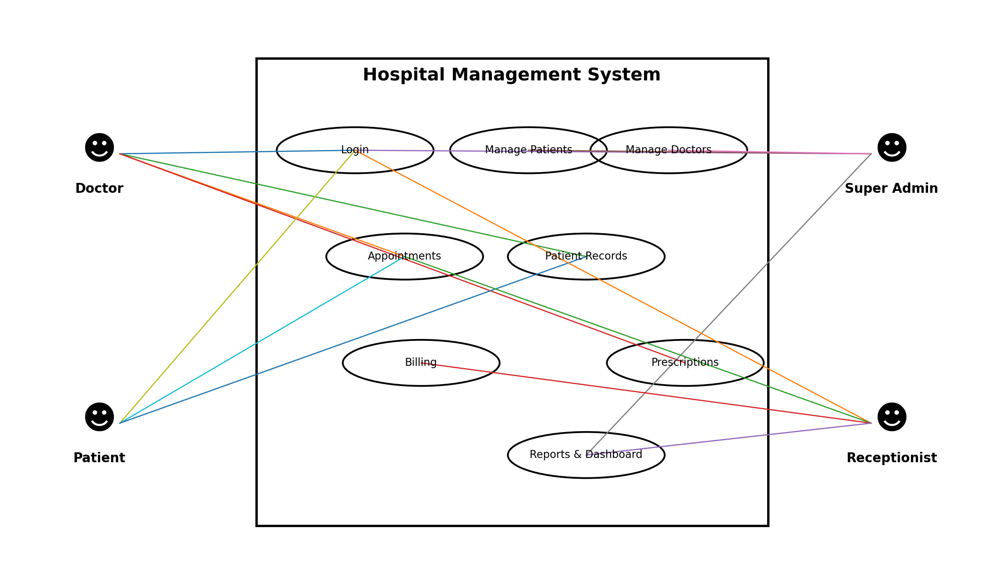
Figure 1: Use Case Diagram – Hospital Management System

Use Case Explanation
- Super Admin: Login, manage users, manage doctors, manage system records, and view reports/dashboard.
- Doctor: Login, view appointments, view authorized patient records, manage prescriptions, and update medical information.
- Patient: Login, view appointments, view doctor information, and view authorized prescriptions/medical records.
- Receptionist: Login, register patients, manage appointments, check doctor availability, and manage permitted billing activities.

PROJECT REVIEW FOCUS
The primary focus of the proposed Hospital Management System is to reduce time consumption in routine hospital activities by replacing repetitive manual processes with a centralized, role-based digital system.

